**WEEK-2**

**PL/SQL Exercises:**

**Exercise 1: Control Structures**

**1.Customers Table:**

CREATE TABLE customers (

    CustomerID NUMBER PRIMARY KEY,

    CustomerName VARCHAR2(50),

    Age NUMBER,

    Balance NUMBER,

    IsVIP CHAR(1),

    LoanInterestRate NUMBER

);

**Output:** 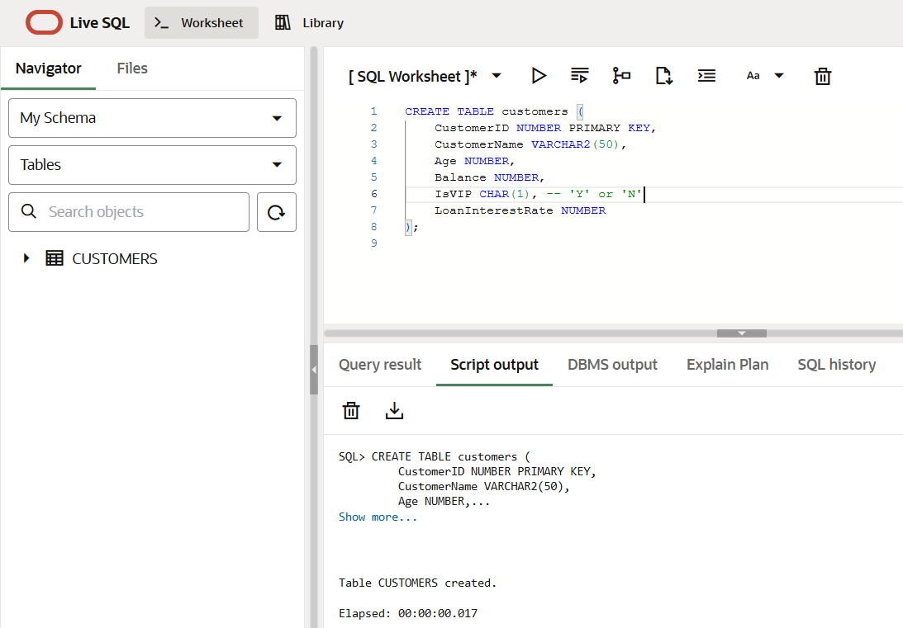

**2.Loans Table:**

CREATE TABLE loans (

    LoanID NUMBER PRIMARY KEY,

    CustomerID NUMBER,

    DueDate DATE,

    FOREIGN KEY (CustomerID) REFERENCES customers(CustomerID)

);

**Output:**

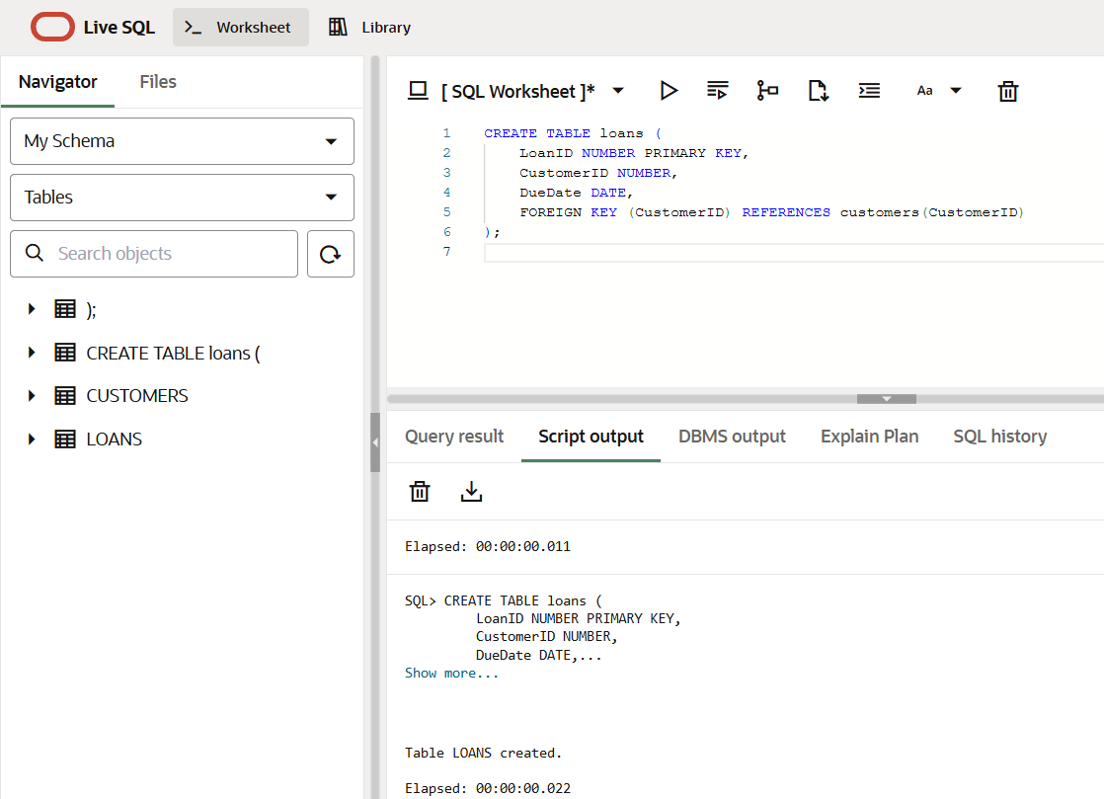

**3.Inserting Values into Customers and Loans:**

-- custom

INSERT INTO customers VALUES (101, 'Alice', 65, 12000, 'N', 10);

INSERT INTO customers VALUES (102, 'Bob', 45, 9500, 'N', 9.5);

INSERT INTO customers VALUES (103, 'Charlie', 70, 15000, 'N', 11);

INSERT INTO customers VALUES (104, 'Diana', 35, 5000, 'N', 8.5);

-- loans

INSERT INTO loans VALUES (201, 101, SYSDATE + 10);

INSERT INTO loans VALUES (202, 102, SYSDATE + 45);

INSERT INTO loans VALUES (203, 103, SYSDATE + 5);

INSERT INTO loans VALUES (204, 104, SYSDATE - 2);

COMMIT;

**Output:**

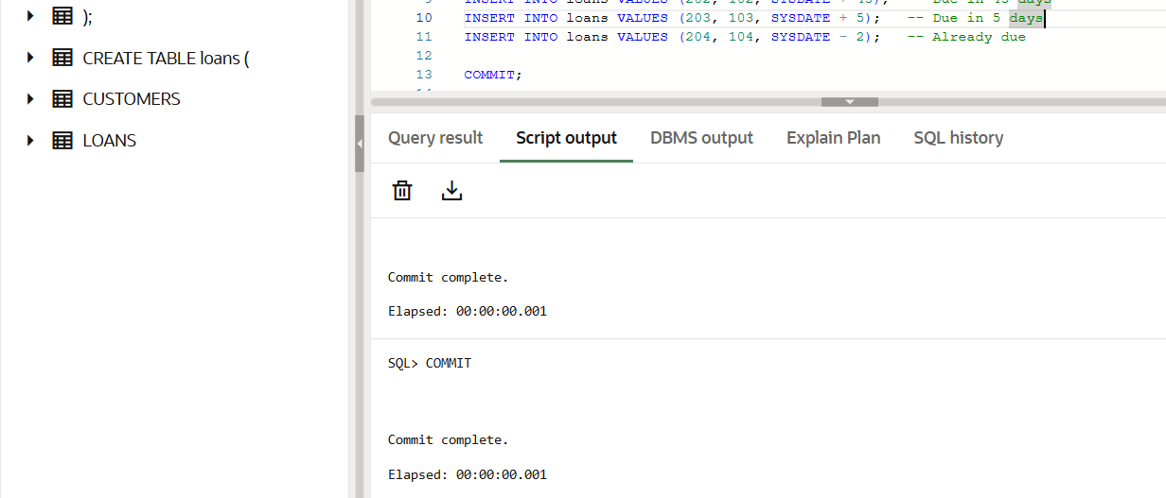

**4. 1% discount to their current loan interest rates:**

BEGIN

    FOR cust_rec IN (

        SELECT CustomerID, Age FROM customers

    ) LOOP

        IF cust_rec.Age > 60 THEN

            UPDATE customers

            SET LoanInterestRate = LoanInterestRate - 1

            WHERE CustomerID = cust_rec.CustomerID;

        END IF;

    END LOOP;

    COMMIT;

END;

/

**Output:**

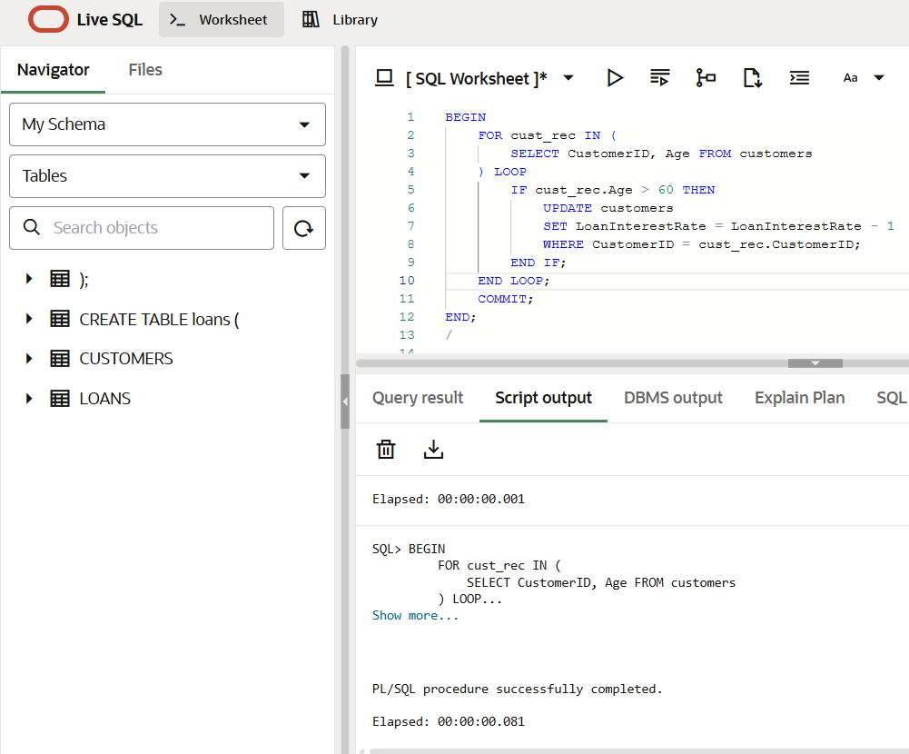

**5.VIP status based on balance**

BEGIN

    FOR cust_rec IN (

        SELECT CustomerID, Balance FROM customers

    ) LOOP

        IF cust_rec.Balance > 10000 THEN

            UPDATE customers

            SET IsVIP = 'Y'

            WHERE CustomerID = cust_rec.CustomerID;

        END IF;

    END LOOP;

    COMMIT;

END;

/

**Output:**

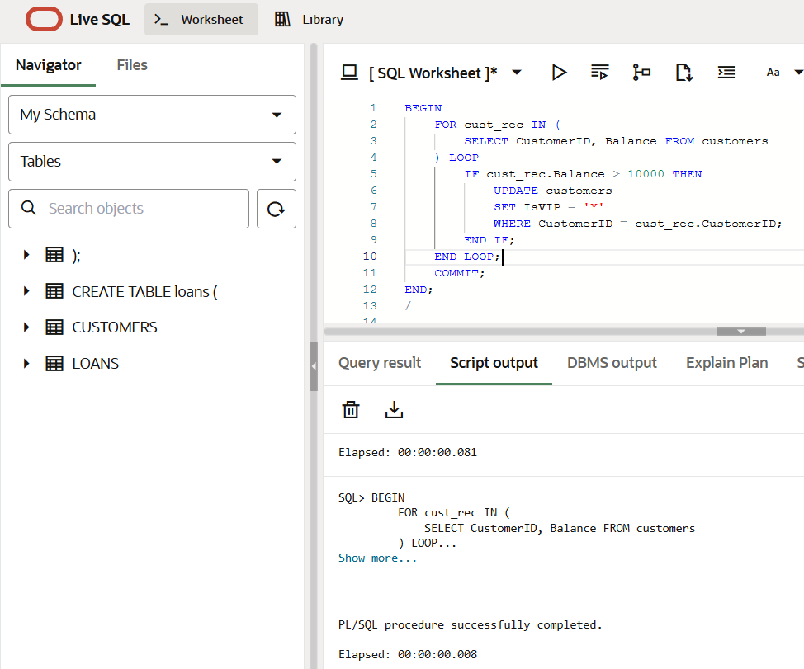

**6. Loan dues and sending remainders:**

BEGIN

    FOR loan_rec IN (

        SELECT l.LoanID, c.CustomerName, l.DueDate

        FROM loans l

        JOIN customers c ON l.CustomerID = c.CustomerID

        WHERE l.DueDate <= SYSDATE + 30

    ) LOOP

        DBMS_OUTPUT.PUT_LINE('Reminder: Loan ' || loan_rec.LoanID ||

                             ' for ' || loan_rec.CustomerName ||

                             ' is due on ' || TO_CHAR(loan_rec.DueDate, 'DD-Mon-YYYY'));

    END LOOP;

END;

/

**Output:**

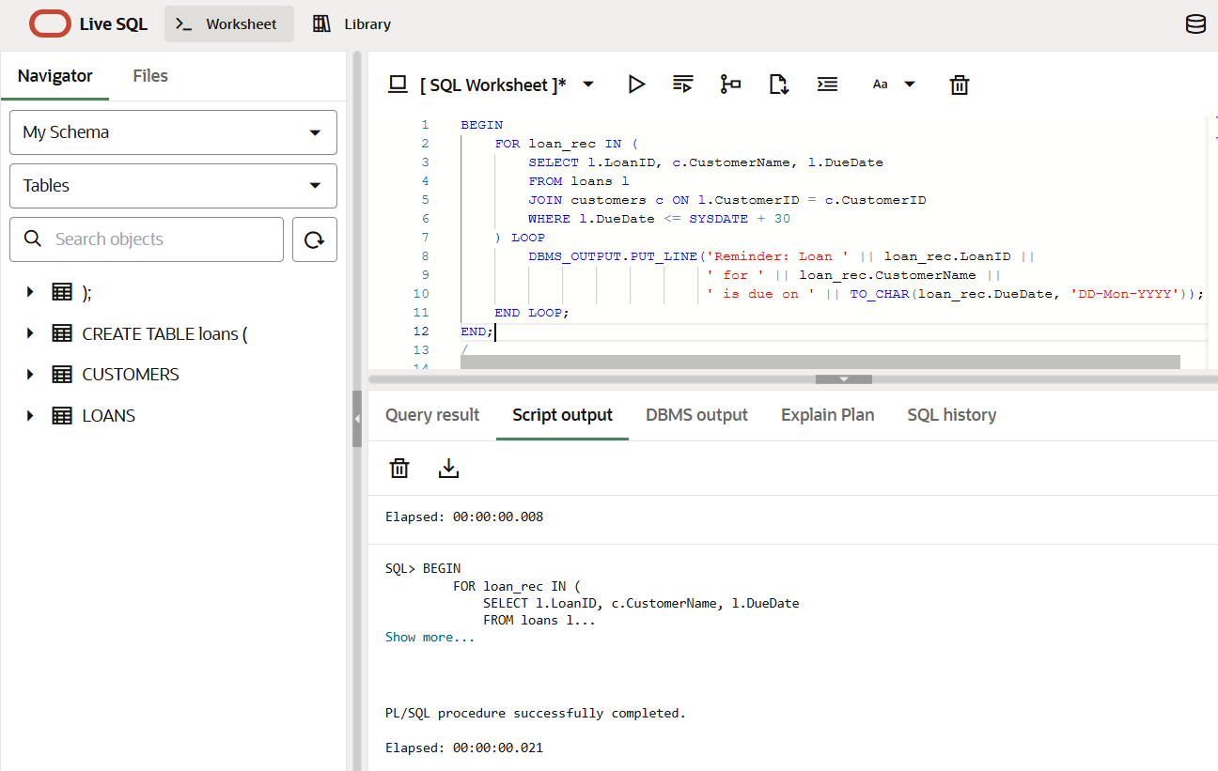

**7.Testing File:**

BEGIN

    DBMS_OUTPUT.PUT_LINE('--- All Customers ---');

    FOR rec IN (SELECT * FROM customers) LOOP

        DBMS_OUTPUT.PUT_LINE(

            'CustomerID: ' || rec.CustomerID || ', Name: ' || rec.CustomerName ||

            ', Age: ' || rec.Age || ', Balance: ' || rec.Balance ||

            ', IsVIP: ' || rec.IsVIP || ', Interest: ' || rec.LoanInterestRate

        );

    END LOOP;

END;

/

-- to display loans

BEGIN

    DBMS_OUTPUT.PUT_LINE('--- Loans Due in Next 30 Days ---');

    FOR rec IN (

        SELECT LoanID, CustomerID, TO_CHAR(DueDate, 'DD-Mon-YYYY') AS DueDate

        FROM loans

        WHERE DueDate <= SYSDATE + 30

    ) LOOP

        DBMS_OUTPUT.PUT_LINE(

            'LoanID: ' || rec.LoanID || ', CustomerID: ' || rec.CustomerID || ', DueDate: ' || rec.DueDate

        );

    END LOOP;

END;

/

**Output:**

